AP Chemistry Unit 7a: Chemical Equilibrium
Name: ______________________ Date: ______________ Period: ______

Learning goals
- Explain equilibrium as a dynamic state and interpret graphs of rate and concentration.
- Write K_{c} and K_{p} expressions and explain what the size of K means.
- Use ICE tables (with concentrations or partial pressures) to find K or equilibrium amounts.
- Change K when a reaction is reversed, scaled, or added to other reactions.
- Use Q to decide which way a reaction will shift.
- Use Le Châtelier's principle to predict the effect of stresses.

1. What Is Equilibrium?
A reaction is reversible when the products can react to re-form the reactants. We show this with a double arrow, ⇌.
Define chemical equilibrium in terms of the forward and reverse reactions:

What happens to the concentrations (or pressures) at equilibrium?

Example: A + B ⇌ C + D
Once equilibrium is established, describe (1) the rates of the forward and reverse reactions and (2) the concentrations of A, B, C, and D:

Start with only A and B. On the axes, sketch the forward rate and the reverse rate over time, and mark when equilibrium is reached.
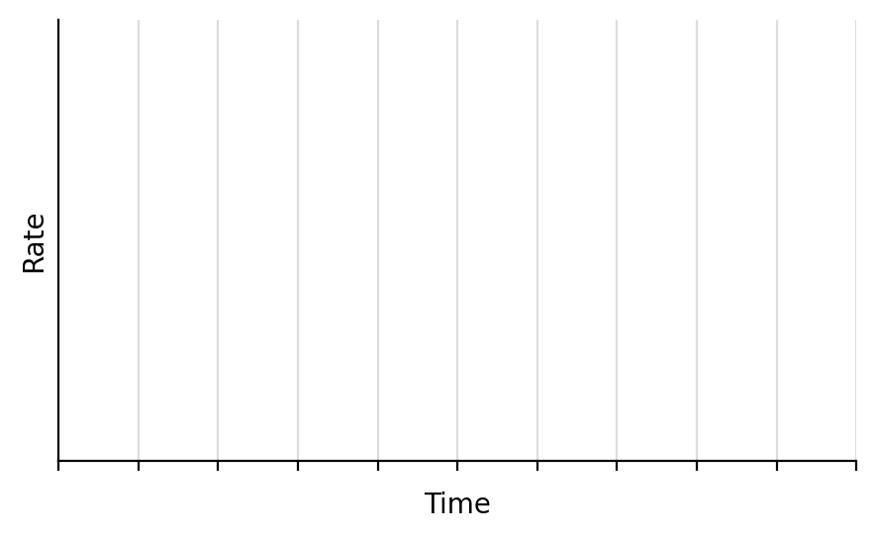

Example: 2NO₂(g) ⇌ N₂O₄(g)
The initial pressure of NO₂ is 3.0 atm and no N₂O₄ is present. At equilibrium the pressure of NO₂ is 1.0 atm. Graph pressure vs. time for both gases. Label the axes with intervals (a scale for the vertical axis).

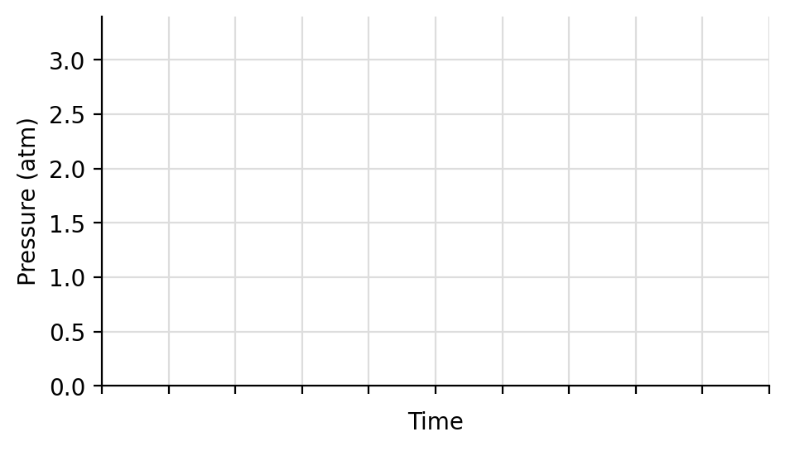
a) Pressure of N₂O₄ at equilibrium: ______
b) Total pressure at equilibrium: _______
c) K_{p} =

2. The Law of Chemical Equilibrium
For the reaction aA + bB ⇌ cC + dD:
Write the general expressions for K_{c} and K_{p}:

Rules for writing K
List the rules for writing K (top vs. bottom, exponents, what is left out, K_{c} vs. K_{p}, units, and what changes K):

What does the size of K mean?
Range of K | Meaning at equilibrium
K ≪ 1
K ≫ 1
K = 1
K > 1.0 × 10⁷

What does K tell us about a reaction, and what does it NOT tell us?

Example: Write the equilibrium expression for CaCO₃(s) ⇌ CaO(s) + CO₂(g)

K_{c} = _______________ K_{p} = ________________

Example: Write K_{c} and K_{p} for 2NH₃(g) ⇌ N₂(g) + 3H₂(g)

3. Solving for K and Concentrations Using an ICE Table
I = Initial, C = Change, E = Equilibrium.
List the steps for solving an ICE table problem:

Example: COCl₂(g) ⇌ CO(g) + Cl₂(g)
3.0 mol of COCl₂ are added to a 1.5 L container at 650 K. At equilibrium [COCl₂] = 0.25 M. Calculate K_{c} and describe the equilibrium as reactant favored, product favored, or neither.
 | [COCl₂] | [CO] | [Cl₂]
I
C
E

Example: 2NH₃(g) ⇌ N₂(g) + 3H₂(g)
3.0 mol of NH₃ are placed in a 1.5 L container. At equilibrium [NH₃] = 0.5 M. Calculate K_{c} and describe the equilibrium as reactant favored, product favored, or neither.
 | [NH₃] | [N₂] | [H₂]
I
C
E

4. Equilibrium with Partial Pressures (Dalton's Law)
State Dalton's law of partial pressures:

Example: 2H₂(g) + O₂(g) ⇌ 2H₂O(g)
Initial pressures: P_{H₂} = 1.3 atm and P_{O₂} = 1.1 atm. The total pressure at equilibrium is 2.3 atm. Calculate K_{p}.
 | P_{H₂} | P_{O₂} | P_{H₂O}
I
C
E

Example: PCl₅(g) ⇌ PCl₃(g) + Cl₂(g)
The initial pressure of PCl₅ is 1.66 atm. At equilibrium the total pressure is 2.35 atm. Calculate K_{p}.
 | P_{PCl₅} | P_{PCl₃} | P_{Cl₂}
I
C
E

Example: Br₂(g) + I₂(g) ⇌ 2IBr(g), K_{p} = 70
0.25 atm of Br₂ is combined with 0.25 atm of I₂. What is P_{IBr} at equilibrium? What is the total pressure?
 | P_{Br₂} | P_{I₂} | P_{IBr}
I
C
E

5.

When Can We Ignore −x? (Small K Approximation)
When can we use the small-x approximation? Describe the conditions and what it lets us do:

Example: H₂CO₃(aq) ⇌ H⁺(aq) + HCO₃⁻(aq), K_{c} = 4.3 × 10⁻⁷
Determine [HCO₃⁻] if the initial [H₂CO₃] = 1.20 M.
 | [H₂CO₃] | [H⁺] | [HCO₃⁻]
I
C
E

Example: N₂(g) + O₂(g) ⇌ 2NO(g), K_{c} = 4.2 × 10⁻⁸
The initial [N₂] = 0.085 M and [O₂] = 0.038 M. What is [NO] at equilibrium?
 | [N₂] | [O₂] | [NO]
I
C
E

6. Manipulating Reactions and the Effect on K
If you… | Then K…
Multiply all coefficients by n
Reverse the reaction
Add two or more reactions together

Example: 2A + B ⇌ 3C, K_{c} = 2.5 × 10⁻³
How does each change affect K_{c}?
a) 4A + 2B ⇌ 6C K_{c} = (coefficients ×2)
b) A + ½B ⇌ (3/2)C K_{c} = (coefficients ×½)
c) 3C ⇌ 2A + B K_{c} = (reversed)
Example: Calculate K_{c} for 2N₂O + 3O₂ ⇌ 2N₂O₄
Rxn 1: 2N₂ + O₂ ⇌ 2N₂O K_{c} = 1.2 × 10⁻³⁵
Rxn 2: N₂O₄ ⇌ 2NO₂ K_{c} = 4.6 × 10⁻³
Rxn 3: ½N₂ + O₂ ⇌ NO₂ K_{c} = 4.1 × 10⁻⁹
Goal: manipulate the given reactions so they add up to the overall reaction. Manipulate K in the same way.

7. The Reaction Quotient (Q)
Define the reaction quotient, Q:

How is Q different from K?

Comparison | Meaning | Shift
Q < K
Q = K
Q > K

Steps: (1) write Q, (2) substitute the current values (change moles to M if needed), (3) compare Q to K, (4) decide the shift.
Example: N₂(g) + 3H₂(g) ⇌ 2NH₃(g), K_{p} = 1.64 × 10⁻⁴
A closed vessel contains 1.5 atm N₂, 3.2 atm H₂, and 0.75 atm NH₃.
a) How do we check if the reaction is at equilibrium?

b) Is the reaction at equilibrium? If not, which way does it shift?

Example: SO₂Cl₂(g) ⇌ SO₂(g) + Cl₂(g), K_{c} = 0.078 at 100 °C
0.035 mol SO₂, 0.500 mol SO₂Cl₂, and 0.080 mol Cl₂ are combined in a sealed 5.00 L flask at 100 °C. Is the reaction at equilibrium? If not, which way does it shift?

Example: At 445 °C, K_{c} = 0.020 for 2HI(g) ⇌ H₂(g) + I₂(g)
[HI] = 2.0 M, [H₂] = 0.50 M, [I₂] = 0.10 M. Which statement is TRUE?
(a) Q_{c} = K_{c}; the system is at equilibrium.
(b) Q_{c} is less than K_{c}; more H₂ and I₂ will be produced.
(c) Q_{c} is less than K_{c}; more HI will be produced.
(d) Q_{c} is greater than K_{c}; more H₂ and I₂ will be produced.
(e) Q_{c} is greater than K_{c}; more HI will be produced.

8. Le Châtelier's Principle
State Le Châtelier's principle:

What does a shift right or left mean? Does a shift fully cancel the stress?

There are 4 types of stress: concentration, temperature, volume of gases, and volume of solutions.

Stress 1: Concentration (or Partial Pressure)
Stress | Q compared with K | Shift
Add a reactant
Remove a reactant
Add a product
Remove a product

What happens if a solid or pure liquid is added or removed?

Example: N₂(g) + 3H₂(g) ⇌ 2NH₃(g)
Fill in the effect on each species as the system shifts. Use ↑ (increases), ↓ (decreases). The arrows describe what happens after the stress, as the system shifts.
Stress | Shift | [N₂] | [H₂] | [NH₃]
Add N₂
Add H₂
Add NH₃
Remove NH₃

(The added or removed substance itself moves back part of the way toward its original value as the system shifts.)
Example: N₂O₄(g) ⇌ 2NO₂(g)
a) Write K_{c}:

b) The system is at equilibrium. At the dashed line, extra NO₂ is added. Sketch how both concentrations change until a new equilibrium is reached.
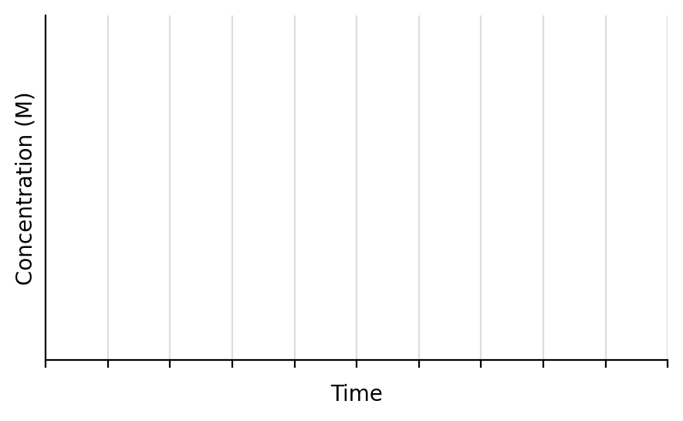
c) Use Q to explain:

d) On the graph below, show what happens if extra N₂O₄ is added instead. Use Q to explain.
Use Q to explain:

Stress 2: Temperature
What is affected by temperature?

To predict the shift, write heat into the equation:
Reaction type | ΔH | Heat is a… | Increase T | Decrease T | K when T increases
Exothermic
Endothermic

Example: Exothermic: A + B ⇌ C + heat, K_{c} = 200 at 25 °C
The temperature is increased to 30 °C. Shift: _____________ K: _____________
The temperature is lowered to 20 °C. Shift: _____________ K: _____________
Example: Endothermic: heat + A + B ⇌ C, K_{c} = 200 at 25 °C
The temperature is increased to 30 °C. Shift: _____________ K: _____________
The temperature is lowered to 20 °C. Shift: _____________ K: _____________

Example: N₂(g) + 3H₂(g) ⇌ 2NH₃(g), ΔH = −92 kJ/mol
a) Where is the heat in the reaction?

b) The temperature is lowered. Which way does it shift? Use K and Q to explain.

Stress 3: Volume of Gases (change in container size)
Example: N₂(g) + 3H₂(g) ⇌ 2NH₃(g)
The reaction is at equilibrium in a 3.0 L container. The gases are moved into a 1.5 L container. Use Q to explain the effect on equilibrium.

Fast way to determine the shift:
Fast way to determine the shift for volume changes of gases:

Stress 4: Volume of Solutions (adding solvent)
Example: HC₂H₃O₂(aq) ⇌ H⁺(aq) + C₂H₃O₂⁻(aq), K_{c} = 1.8 × 10⁻⁵
a) Write K_{c}:

b) 2.0 L of H₂O is added to 1.0 L of 1.0 M acetic acid. Do the moles of C₂H₃O₂⁻ increase, decrease, or stay the same? Use Q to explain.

Fast way to determine the shift when solvent is added or removed:

Non-stressors: things that do NOT shift equilibrium
Catalyst: what does it do to equilibrium?

Surface area of a solid reactant: what does it do to equilibrium?

Adding a non-reactive gas (constant volume): what does it do to equilibrium?

9. Summary
Stress | Shift | Does K change?
Add reactant / remove product
Add product / remove reactant
Increase T (endothermic)
Increase T (exothermic)
Decrease volume (gases)
Increase volume (gases)
Add solvent (dilute)
Catalyst, solid surface area, inert gas

